## The current state of the guitar amp tone debate: tube amps, pedals, solid state and digital modelling/profiling

Anyone who plays electric guitar in our time has very likely stumbled upon more than one YouTube video showcasing some piece of equipment. Looking it up ourselves or having it shown to us either by a friend or by “the algorithm”, these days gear talk on the internet is all but inevitable for musicians. In fact, it’s safe to say that it has become a fundamental part of forming one’s opinions. YouTube videos and their comments section, Instagram posts and internet forums such as The Gear Page, VI-Control or Gear Space are now places where groups form[^groupFormation] around reverence or disdain for certain pieces of equipment, in an interesting shift away from the classic sociologically-friendly cleavages of old, based as they were on musical genres and how they map onto identity. It is true that the divided opinions around, say, a pedal like the Klon Centaur or Fender amplifiers have existed long before “forum culture”[^forumCulture] became a thing, but it seems to me that internet forums and social media helped make the act of throwing a Social Sciences-informed gaze on how people address their gear choices considerably more productive and rich.

The present article unfolds in the following manner: first, we’ll briefly discuss some relationships between technology and democratization in our time. Then we’ll go over general points about guitar amplifier technology so that we can approach the current debate on digital guitar amplifiers and how this taps into the more general theme of equipment preference, choice, access to culture consumption and creation, and, coming full-circle, the role technology plays in all this.

The main underlying theme I’d like us to keep in mind here is that of democratization, so it might be worth at this point tracing a basic (if somewhat crude) outline of how I’m thinking of the convoluted relationship between democracy and technology in our age. Democracy and its advances and reverses throughout History form a complex theme that obviously can’t be dealt with here,[^deibert] so let us limit our scope right from the start. I am particularly interested in forces that enable people to acquire knowledge and broadcast what they make with that knowledge. More specifically, I want to investigate how people’s artistic aspirations can be set in motion and eventually released. In principle, an increase in the circulation and the variety of ideas and artistic works would eventually feed back into more general democratizing processes such as demands for rights and representation or struggles against oppression.[^darnton]

Technology has been thus hailed as an enabler of democratization - hence a democratizing force in itself - at least since the beginning of the internet age[^internetAndTech], and today more than ever there’s practically no technological affair that isn’t *connected* to the internet - the pun wasn’t intentional, but ended up being useful. Covering a broad spectrum that touches on digital rights activism, the free culture movement, Wikipedia, the blogosphere (remember that?), “copyfight”, software and media piracy, free and open source software, crowdfunding, self-publishing initiatives, cryptocurrencies, podcasting, “value-for-value” initiatives, grassroots journalism, the so-called Arab Spring and even YouTube, technology is the common enabler to all of these phenomena. Phenomena that, by its turn, can be regarded as democratizing in a sense or another.

### Guitar software and hardware

There are several points of entry when it comes to discussing democratization and technology involving music. For instance, streaming and piracy made entire song catalogs immediately available to anyone with an internet-connected device, while tech-deflation[^techDeflation] put formerly inaccessible “studio-grade” gear in the bedrooms of hobbyists. Music software is especially characteristic of the larger phenomenon outlined here: musical sounds such as a symphony orchestra, ambience like that of a reverb chamber or the tone and affordances of an all-analog Neve console, previously attainable only to artists signed to a big recording label with a correspondingly big budget, are now accessible to virtually anyone in the form of a software plugin.

A great deal of music software is based on coveted pieces of gear, sometimes building upon it but often trying to replicate it as faithfully as possible, including its user interface. We’ll discuss a few of the methods employed to replicate physical gear in software form and explore its implications below, but the main thing to bear in mind at this point is that, compared to the hardware it often “emulates”,[^emulation] software is cheaper (potentially free if we consider piracy), takes less space, is easier to carry around, can be used in much quieter volumes, and consumes less power. All this makes working “in-the-box”[^inTheBox] significantly more attainable to those who can’t resort to a traditional studio or something similar. It costs a lot more money to book studio time and the price follows the equipment it possesses,[^studioMojo] but there are also expenses to be accounted for in going to the studio. First, the distance and corresponding travel time and gas costs. Second, the time slot one must block to be able to spend some hours in that space, as opposed to those who squeeze some music-making at home between other activities. Finally, there’s the knowing part: the people, where to go, the vocabulary and the codes to interact in a professional studio.

Software can either be considered easier or harder to use depending on the user’s skill and mindset, but it offers a *kind* of flexibility that hardware rarely achieves–as long as one is working within the constraints of what the product’s maker–be it either software or hardware–envisioned.[softwareVsHardwareFlexibility] First of all, software can be made more tweakable: changing the speaker of a software amp to get a different tone can be done in one or two clicks or, in the worst case scenario, through a download followed by the installation of some form of impulse-response or similar technology[^impulseResponses]. A hardware analog amp, by its turn, requires that one buys the speaker and actually goes through the process of removing the old speaker, inserting the new one, soldering connections etc., in a process that usually requires specialized knowledge and includes potentially life-threatening procedures.

Moreover, users can combine software with other pieces of software, can use it in series or in parallel with itself multiple times, can split what it does according to different parameters etc. For example: think about passing a guitar signal through three VOX AC30s with the purpose of achieving whatever three AC30s stacked could do: first of all, you’d have to have three units of this fairly expensive amp. Then each one would have to be mic’ed, hopefully minimizing bleed from one to the other, so you’d need three microphones (assuming you’d use only one mic for each) and a room with space and treatment adequate to handle the volume and the specific sound propagation situation that will be created. One surely couldn’t do it in a condo, so think about a studio that offered such a structure to perform this in the analogue realm. This is all trivial with software and is generally equated to offering a degree of flexibility virtually impossible in the physical realm:

[COLOCAR ALGUMA FALA QUE EXEMPLIFIQUE ISSO]

However, usually hardware gear allows for a kind of intervention on its inner workings that is rare in software due to it requiring, 1, that the source code is available and, 2, that the people interested in working on it have the technical expertise to do so. Granted, not every guitarist has the knowledge and ability to get a soldering iron and start messing with pedals, let alone amps. But somehow - at least until the current kids reach adulthood - this is generally considered a lower barrier of entry than tinkering with Digital Signal Processing and the like. This can be verified by the abundance of modding, DIY and BYOC[^moddingDIYBYOC] forums and by how frequently this route is suggested in discussions in other forums. Conversely, at least to my knowledge, someone suggesting a fellow guitarist should go mess with a plugin’s code is fairly unusual. Maybe there is something here related to the fact that doing small fixes on one’s own instrument is usually regarded as an ability a professional musician should possess, and then perhaps it passes over to hardware equipment in general. Software (so far) doesn’t occupy a similar position and, as I said above, at the very least one needs to have access to the programs’ source code to be able to modify it, which is in itself something rare in an industry that is built around the (supposed or real) exclusivity and uniqueness of each maker’s algorithms, transforms, implementations etc.[^examplesOfIndustryHype] That said, the flexibility alluded to earlier that software possesses can also be thought of as a kind of intervention and is visible in the existence of a huge market for presets, impulse-responses and amp models/profiles. Usually these programs offer the ability to create presets, which are a way to store and later recover settings that the user may have liked or found useful. People sell or share presets they make and the fact that there is such a market for it shows that many users are not even interested in tinkering or learning to tinker with the gain and volume knobs or the EQ section of their software amps and prefer to rely on other users’ ears and ability.[^presetSharingAndCommunity]

All this creates a somewhat predictable divide between the analogue and the digital realms. Some would say that, being different in nature, it would make them incommensurable with regard to the knowledge one could carry from one to the other. At the same time, since music software has the tendency to imitate - sometimes to minute detail - the analogue gear after which it is modelled, it could be expected that regular use could be translated directly. Take as an example the coveted all-analogue Tone King Imperial MKII and the interface of Neural DSP’s digital version of the same amplifier:

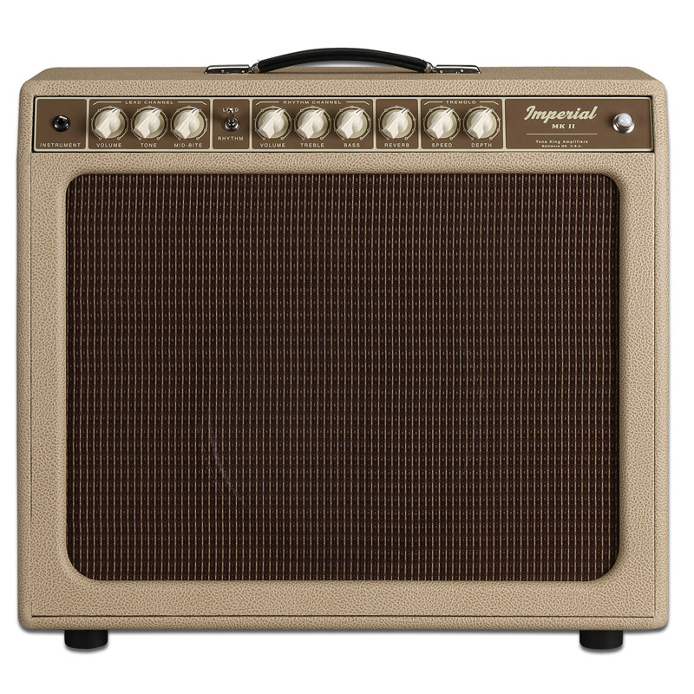 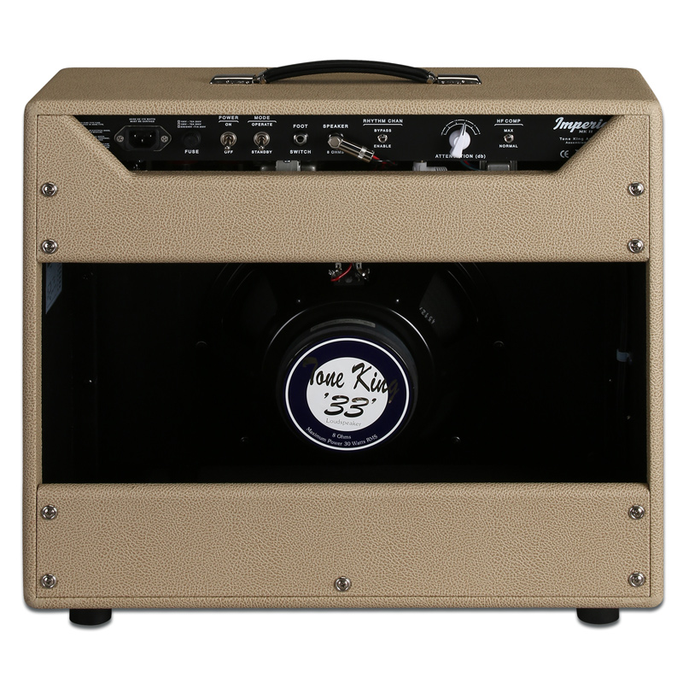

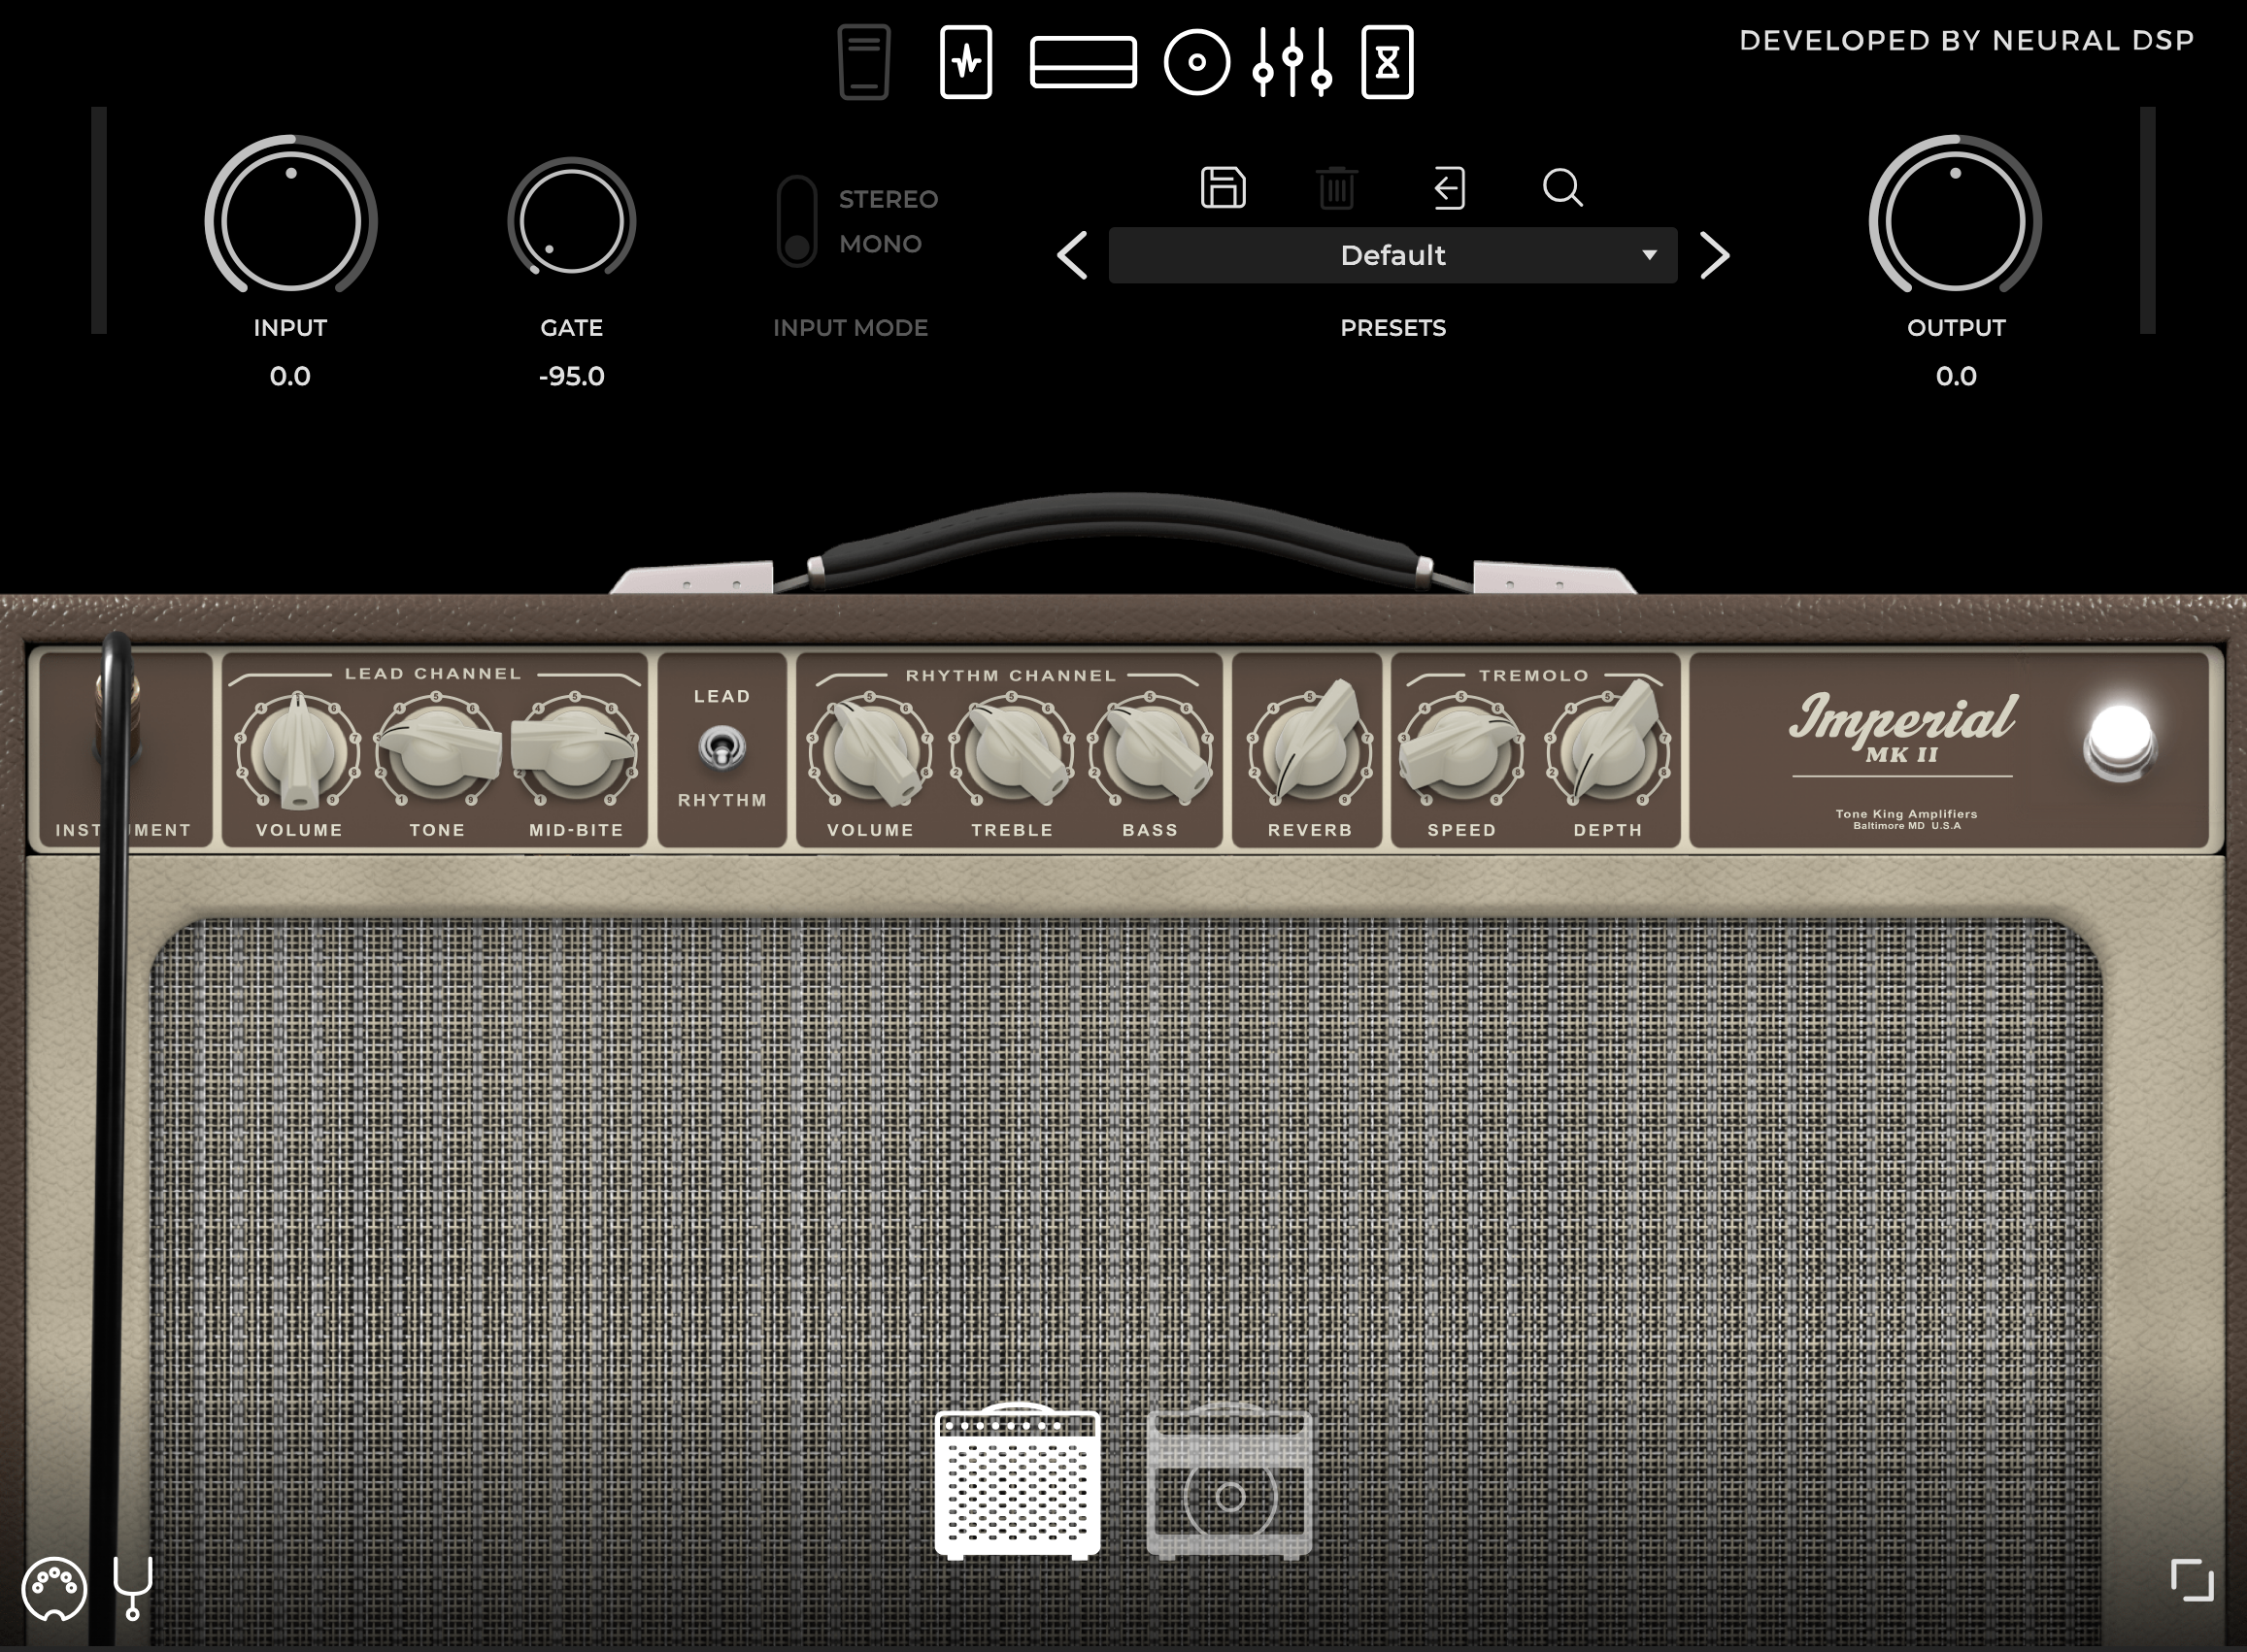 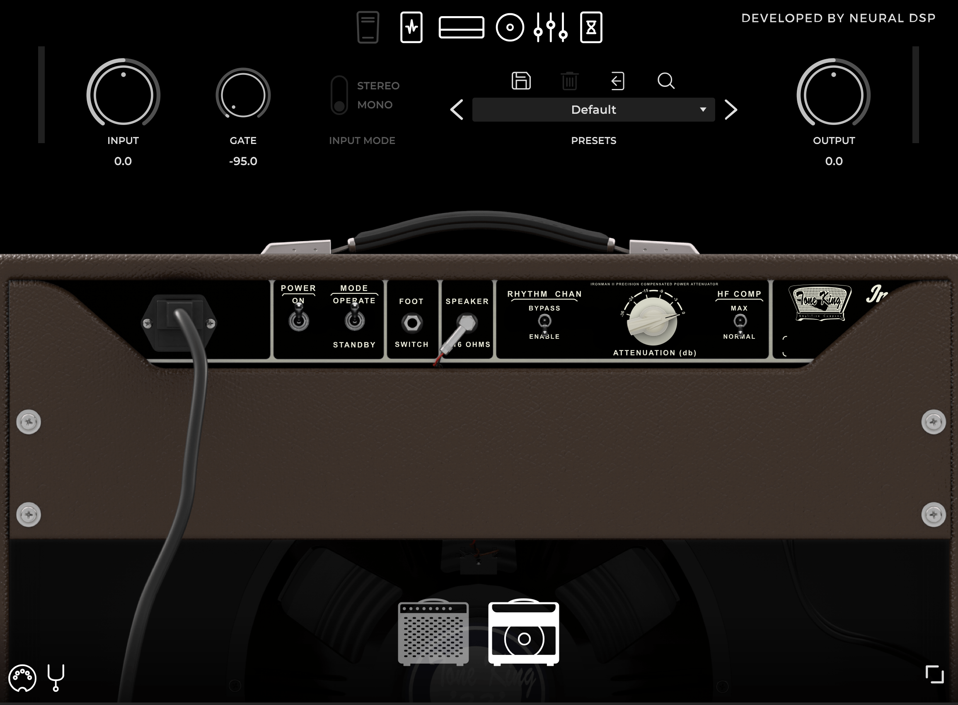

Nevertheless, comparisons between digital versions and “the real deal” are legion. For instance, here’s what turns up in a simple YouTube search (on 2023-11-14) using the query “Neural DSP Tone King Imperial MKII vs real amp”:

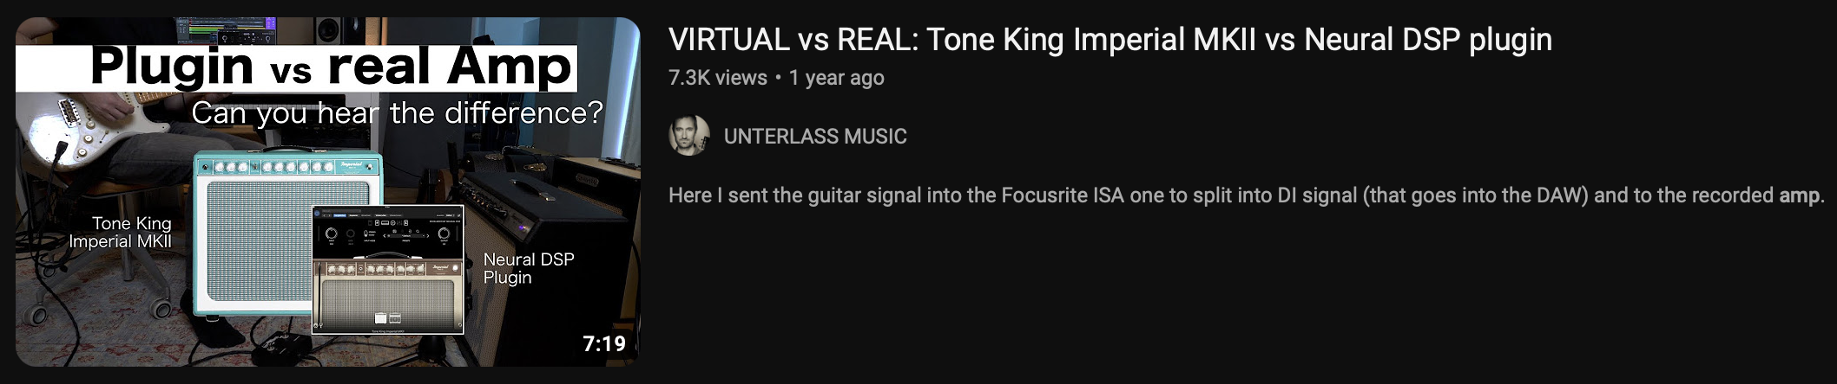 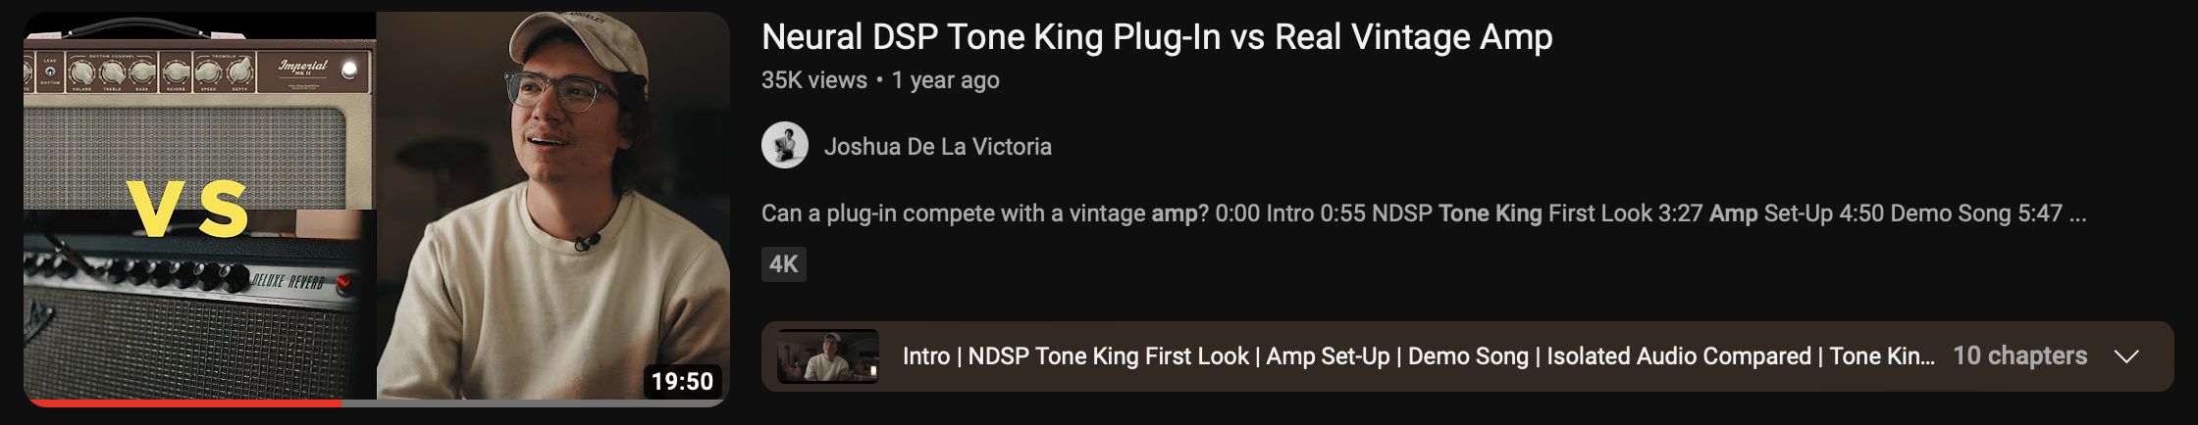 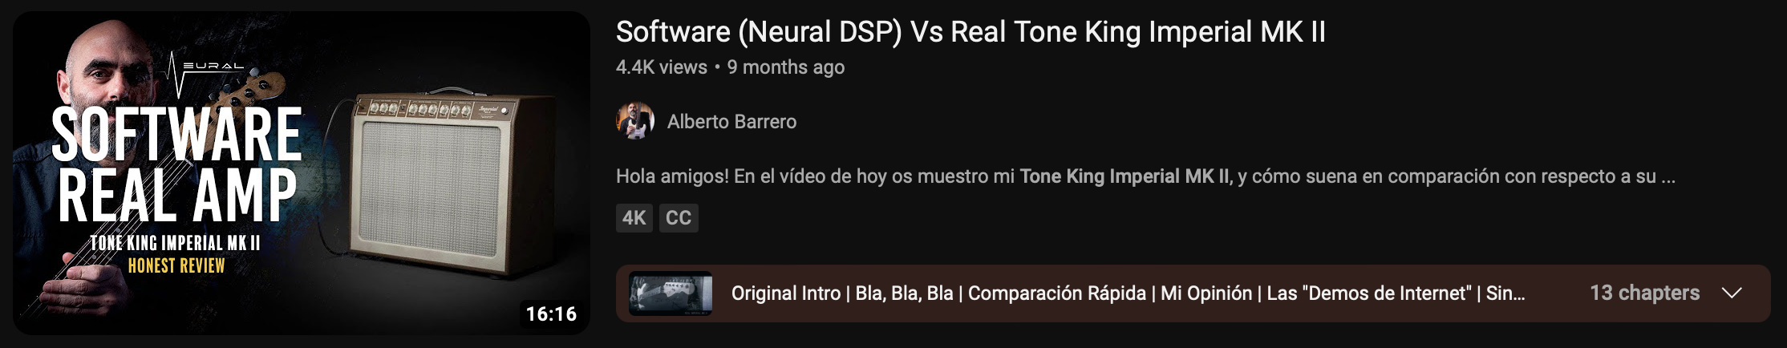 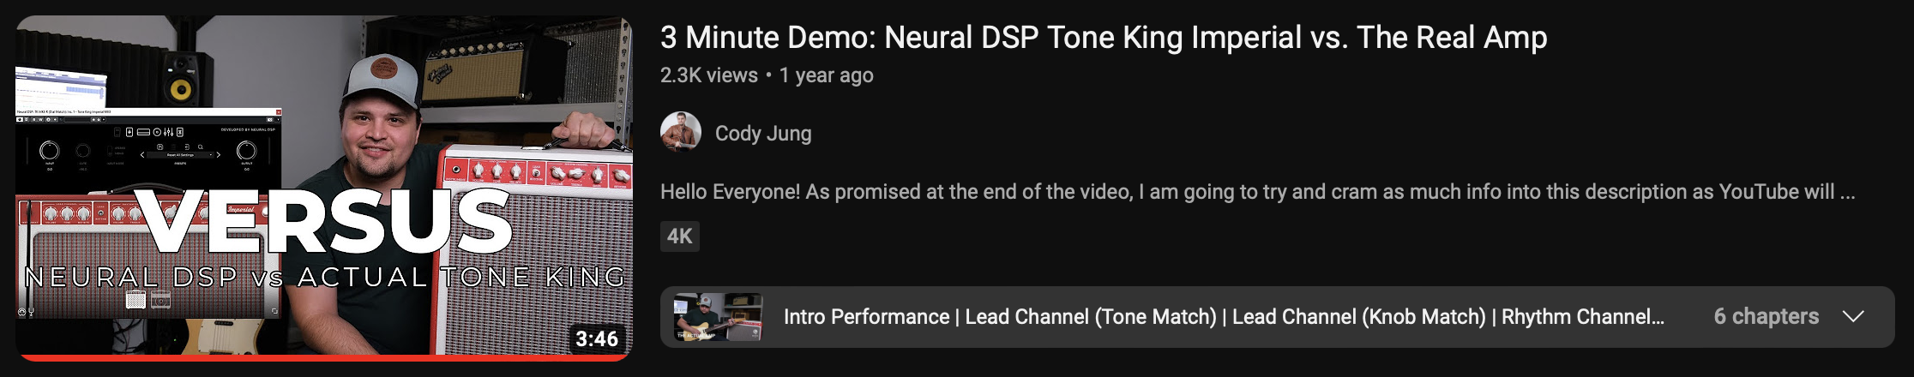 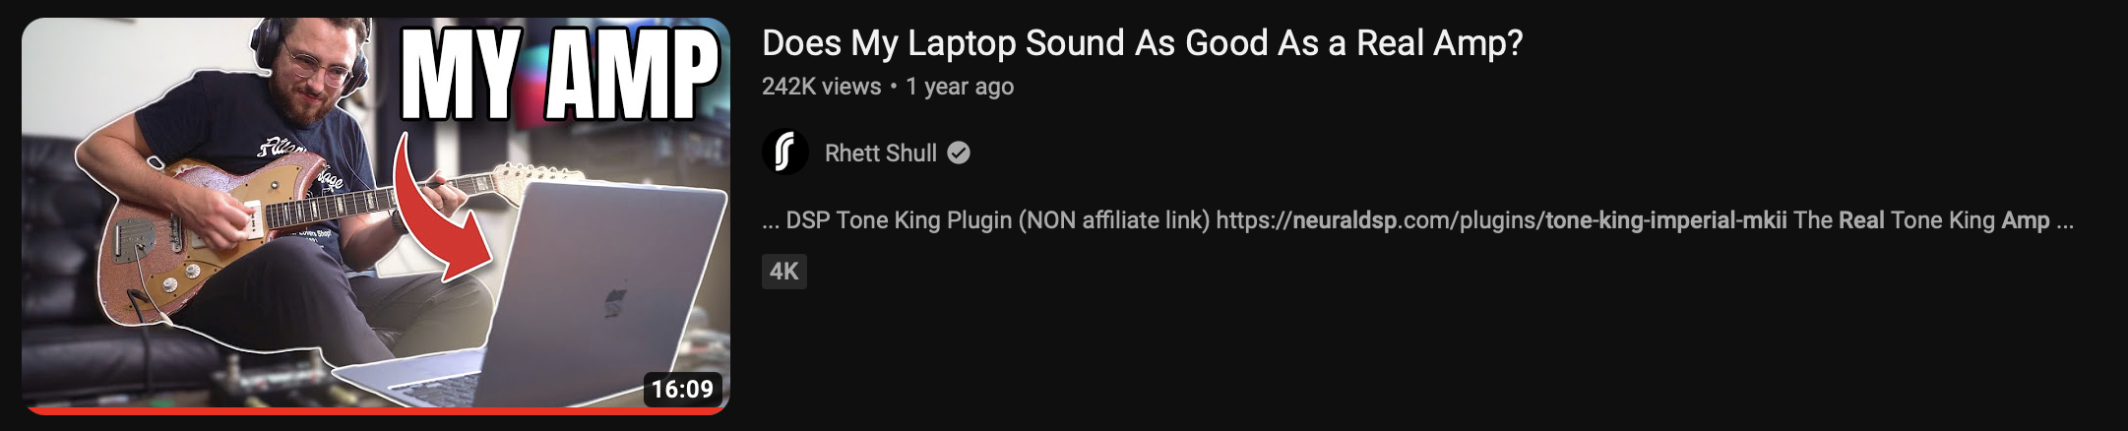

### Tubes, transistors and code

There is a third kind of amplifier that occupies sort of an intermediary position in this discussion: hardware digital amps. These are hardware amps that employ digital technology in some of its components. What the digital part is doing varies considerably from model to model, some being all analogue with only a digital reverb, for example, while others have a great deal of their tone produced by their onboard computers - which is what these are, after all. Many are in fact entirely *solid-state*, employing both digital and analogue tone-producing means, while others are tube amps with digital technology added - like a load box and cabinet simulator,[^loadBoxCabSim] for example -, often including all three technologies spread across different parts of the device. Due to the myriad possibilities and, as a consequence, the challenge of consistently and comparatively addressing the diverse roles digital components may play across various models, here we will basically deal with complete software solutions and full analogue amps, treating them almost like ideal types.[^webersIdealTypes]

Despite the fact that I have been dwelling on the split between the analogue and digital realms and how it pertains to our discussion, I’d like to suggest one more possible categorization. This one doesn’t render the other obsolete, but rather adds another layer to the discussion: tube amps, solid state amps and digital modelling/profiling amps.

All the way until here I’ve been talking about guitar amplifiers, but haven’t really discussed the main technologies themselves. This can be useful at this point, as some other considerations to be made will arise from it.

- vacuum tubes: old technology, basically HiFi equipment and guitar amps  
 - introduce "harmonic distortion" that "we find pleasing"  
 - wattage != loudness  
- solid state amps generally aren't considered capable of offering tube tone  
 - this quickly becomes "aren't capable of good tone" (people say they are sterile-sounding)  
 - division among guitarists: jazzers tend to be much more open to SS (the Roland Jazz Chorus is a staple), but rock/pop/soul/blues/country guitarists who play "mostly clean" tend not to like SS (Tim Lerch on why he prefers tube perhaps implies that it's the case with Teles)  
- the (classic) divide analog vs digital doesn't hold here: SS is analog and people say a SS amp isn't on par with a tube one  
 - there's more people who go back and forth between tubes and digital than those who stick with analog, despite being tube or SS  
- And what about pedals?  
 - people are a little less picky with regard to pedals - pedals are also SS and are used "to push clean, 'pedal platform' (tube) amps into overdrive" - but sometimes they are themselves introducing distortion  
 - some people will still say "I'd rather use a boost", but at the same time it's common to see people praising overdrive pedals for "behaving like a tube amp"  
 - another interesting point is that I've never seen anyone mention the waste of energy that tube amps represent:  
 > "Most of the energy loss in classic amp designs occurs because of the need to keep the power tubes operating in their linear range. To function optimally, tubes need to be at a certain temperature–this is why you need to warm up a tube amp before you play it. Most of the power draw of tube amps goes towards keeping the tubes hot, as opposed to amplifying the guitar signal.  
 > Class D amps function at around 90% efficiency, meaning that only about 10% of the energy put into them gets released as heat. Classic guitar amplifiers convert anywhere from 70% to 90% of the energy they draw from the wall into heat." (https://georgedyermusic.com/2016/11/24/how-do-quilter-amps-work/ Oct 4 2023)  
 - attributed to Pat Quilter: an electron doesn't know if it's a tube or a transistor; you have to voice it right  
 - Josh Scott: germanium vs silicon (talking about different transistors, but the similarity with Quilter's argument is interesting), it doesn't really matter; what matters is how you voice the pedal  
 - The Gear Page user: "Digital modelling might be the missing ingredient in closing the gap between tubes and solid state." (https://www.thegearpage.net/board/index.php?threads/quilter-disappointment.2321918/post-33936105 Oct 4 2023)

## Three camps, two paradigms:

* we can talk about two paradigms: - the traditional paradigm: tube amps, hard (heavy) to carry around, knobs, plug and play, direct control of defined parameters (which are in principle discrete, but there can be a lot of interaction between them when you dig), more flexibility (easier) in terms of how adjust it on the fly (one feature of tube amps is that they change their tone according to temperature and energy source, for example); - the digital paradigm: software emulation (a brief discussion about the word “emulation”), having to scroll through (endless) menus, harder to tweak on the fly, at the same time tone is always the same, so it’s predictable/reliable, light to carry around - but many times you don’t carry because they are in computers at home that “bedroom guitarists” use (vs pros, who graduate to tube amps - but the A-level pros (who play with big acts) have been using (and publicizing) more and more modellers for their dependability and predictability). The solutions for gigging musicians try to bridge the gap between the immediacy of hardware solutions and the main selling points of the digital ones.
  + “Nothing does what a tube does and nothing ever will”
    - Countered by “Ok Boomer” - accusations of elitism, conservatism, superstition
  + “Amp-modelling technology has matured and is now (virtually) indistinguishable
    - Countered by “they’ve never even experienced a tube doing its thing properly due to various circumstances involving generation, financial means, and lack of opportunity (no space to crank an amp, no vintage”true” equipment within reach)
  + Middle ground, various arguments and different positions:
    - “It sounds just like tubes, but feels different under the fingers”
      * Countered by “I’ve never even experienced the real thing… so what it doesn’t feel the same?” - I’ve never seen anyone say it feels different and it’s better this way **and this is something interesting**
    - “It doesn’t sound just like tubes, but it doesn’t matter in practice”
      * Countered by “but what about how the player feels about it?”, “The player plays better if they feel it the way they themselves like it”
      * Also countered by the “Death by a thousand cuts” argument

## The JHS Kemper story

## NAM and the open source discussion

* modelling and profiling
* null tests
* NAM vs Kemper/QC/Fractal/Helix/ToneX/etc
* against elitism, lowering barrier of entry
  + curiously, the argument of “feel” surfaced as the tone became indistinguishable
    - how quick the amp responds (SS is faster, but some people claim - in other contexts, meaning, when discussing only tube amps - that there is difference according to speaker - why not bring the speaker thing in this case too?)
    - mushiness and compression (Quilters usually have a compressor/limiter built-in to match the feel of tube amps, at the same time the Two-Rock guy says he doesn’t like compression and works to have his amps - usually considered state-of-the-art in terms of boutique tube amps - to compress as little as posssible (Dipped in Tone interview))
  + isn’t this “nothing but tubes” thing some form of keeping the outsiders/children in their place?
  + creates the feeling of “when I grow up, I’ll go tubes” - “As most players tend to graduate to tube amps from solid-state amplifiers, they (tube amps) can be known as more aspirational amplifiers – something that you ‘graduate’ to” (https://www.laney.co.uk/blog/solid-state-vs-tube-amps-why-be-forced-to-choose/#:~:text=Solid%2Dstate%20amps%20don%27t,way%20as%20a%20tube%20amp, Oct 4 2023).
  + discussions that tap into the Open Source character of NAM to criticize people selling profiles:
    - “for the people, by the people” or, even better, “for us, by us”, as a user put it
    - misunderstanding of what OSS actually implies and accusations by others of being “freeloaders”

People who know nothing about transistors: https://www.tdpri.com/threads/quilter-amps-what-are-your-thoughts.953963/post-9127734 The thing that bugs me about all the posts that say what you can’t do with transistors is that my guess is that those who are saying that *probably* don’t really know anything about how transistors work. I suppose they might… but anyone who knows how transistors work likely would NEVER say such things.

True… if you take a tube amp and replace each stage with a similar transistor-based stage then what you get will NEVER sound like what a tube amp sounds like. And that is EXACTLY what happened with the very first solid-state amps… and why they sounded bad.

But… transistors are very versatile building blocks and we can put millions of them on a chip and create some very complicated things. And engineers understand precisely how to do these kind of things. And that is what Quilter has done. They use millions of transistors to create circuits that come pretty close to having the same overall input-output function of a tube amp… Is it perfectly the same? Probably not. Is it pretty close? Probably. Will some players be OK with it and others not? Yes. It will depend on the player as well as the job - and its various constraints - that the player is trying to accomplish.

I’ve never played a Quilter amp… nor have a played any other recent solid-state amps. I play either tube amps (that I’ve designed and built myself) or I use a modeling amp (which also use millions or billions of transistors to mimic tubes in a very different way… but the main idea is the same - replace a circuit with a number of tubes that you can count on both hands with millions or billions of transistors). But how do I know that solid-state amplifiers have this potential? Because I’ve been teaching circuits and electronics at the university level for over 20 years. It is very easy to underestimate what *can* be done with transistors - especially if your view is colored by the many horrible SS amps that have been made over the decades. But just because someone built the pinto does not mean that someone else can’t build a Ferrari out of pretty much the same technology.

So… the Quilters probably sound pretty good (because the guy who designed them took a very different approach from what led to the original SS amps) and he has a pretty good track record as an excellent analog circuit designer)… but if you don’t like them that is fine - just don’t say that fundamentally you can NEVER design a SS amp that sounds good.

(mfowler314) - Oct 4 2023

A few posts below: Ian T said: This is why 40+ years later, tube amps continue to prevail in most professional rigs. Tubes and transistors sound different, period. Digital modeling has made better progress than analog solid state, however, but that’s another topic.

Fowler: You are partly right here. Tube amps do still prevail but that is not based solely on the sound of the current generation of SS amps. There are many reasons that tube amps are still preferred by many - myself included (I like them because they sound good, they are simple, and I can design, build, and modify them to my heart’s content). A big part of it is that early SS amps were so horrible… and that makes lots of people (yourself included) constantly imply that *no* SS amp can ever sound good… period. It is a culture thing based on decades of bad SS amps. But you have to admit that today’s SS amps sound nothing like the old ones… they keep getting better. And we are at the point where some players (and not only bedroom players) look at all the factors and decide that a SS amp meets their needs.

[softwareVsHardwareFlexibility]Admitedly this point is far more complex than I can get into here. In a sense, hardware–especially old hardware–is more modifiable and tweakable than software in the sense that it’s a physical machine which one can open and tinker with. Being old technology, chances are it’s a collection of very well-known small pieces put together: capacitors, resistors, tubes, diodes etc. From this perspective, software, on the other hand, requires advanced coding skills but, most of all, access to the source code, which is extremely rare in the music-software industry. That said, as my argument above goes, software can be programmed to be flexible, offering much more built-in options than any piece of analog gear can. With miniaturization and advances in digital equipment, though, there’s a clear tendency of newer hardware to go the same route as software in terms of tinkerability and hacking, going progressively more black-box-y.